A Capstone Project presented to the College of Information
Technology Education PHINMA University of Iloilo
Iloilo City

Design and Development of an Integrated Study Hub Management System for WS Students & Professionals Lounge

Submitted in partial fulfillment of the requirements for the degree of
Bachelor of Science in Information Technology
System Development

Justine Grace G. Reyes
Ramil Fernandez Jr.
Lord Cedrick Cama
Sean Paul Laureano
Mary Karell Encio

UI-FB1-BSIT3-6

2025-26
TABLE OF CONTENTS

Design and Development of Integrated Study Hub Management System of
WS Students & Professionals Lounge------------------------------------------------------------------1 TABLE OF CONTENTS----------------------------------------------------------------------------------2
LIST OF FIGURES------------------------------------------------ 2
Figure Page-------------------------------------------------------------------------- 2
LIST OF TABLES------------------------------------------------- 2
Chapter 1------------------------------------------------------ 1
Introduction to the Study------------------------------------ 1
Technical Background of the Study---------------------------- 4
Statement of the Problem------------------------------------- 7
Objectives of the Study-------------------------------------- 9
Significance of the Study----------------------------------- 11
Scope and Limitations--------------------------------------- 12
Definition of Terms----------------------------------------- 15
Chapter 2: Literature Review---------------------------------- 18
Overview of File Sharing------------------------------------ 18
Traditional vs. Modern File Sharing------------------------- 19
Technologies on the book titled Network Security Foundation- 20
Technologies on the book titled Computer Networking--------- 21
File Transfer Protocols and File Sharing Protocols---------- 22
Attacking Authentication------------------------------------ 25
Case Studies------------------------------------------------ 27
File Share Using Microsoft Windows Network------------------ 27
FTP Credential Theft, Web Page Injection and Web Page
Compromise-------------------------------------------------- 30
Conceptual Framework:--------------------------------------- 33
Chapter 3----------------------------------------------------- 34
Methodology------------------------------------------------- 34
Research and Development Stage------------------------------ 38
System Development Life Cycle:------------------------------ 40
Agile Development Methodology with Scrum Framework:--------- 42
Data Collection Techniques:--------------------------------- 43
System Architecture and Design------------------------------ 46
ⅤPHINMA UNIVERSITY OF ILOILO
College of Information Technology Education
System Architecture----------------------------------------- 46
System Components and Modules------------------------------- 48
Security and Access Control Module-------------------------- 50
System Architecture and Design------------------------------ 51
Use-Case Diagram-------------------------------------------- 54
Entity-Relationship Diagram--------------------------------- 57
Programming Languages and Tools Used:----------------------- 58
Database Design--------------------------------------------- 58
User Interface Design--------------------------------------- 62
Security Considerations------------------------------------- 64
Technology Stack-------------------------------------------- 65
Survey Questions for System Assessment---------------------- 68
Sampling Methods for Respondents---------------------------- 73
Data Analysis Techniques------------------------------------ 75
Methods for Processing Raw Data----------------------------- 76
Frameworks for Evaluating System Effectiveness-------------- 77
Ethical Considerations-------------------------------------- 78
Chapter IV---------------------------------------------------- 80
Result and Interpretation----------------------------------- 80
Task Manager:-------------------------------------------- 81
Gantt Chart / Project Timetable----------------------------- 81
CHAPTER V---------------------------------------------------- 228
Conclusion------------------------------------------------- 229
Recommendation--------------------------------------------- 230
Final Thoughts--------------------------------------------- 230
Appendix A: System Interface Screenshots-------------- 231
Appendix B: Use Case Diagram-------------------------- 235
Appendix C: Data Flow Diagram------------------------- 236
Appendix D: User Survey Form and Summary-------------- 23

LIST OF FIGURES
Figure Page
Figure 1. Agile Development Methodology-----------------------------------------------------------22
Figure 2. System Architecture Diagram----------------------------------------------------------------27
Figure 3. Data Flow Diagram----------------------------------------------------------------------------31
Figure 4. Use-Case Diagram------------------------------------------------------------------------------31
Figure 5. Entity Relationship Diagram------------------------------------------------------------------34

CHAPTER 1

1.1 Introduction to the Study

WS Students & Professionals Lounge – La Paz Branch currently operates using a combination of manual, paper-based processes and spreadsheet-based recordkeeping, along with social media platforms such as Facebook and Messenger for handling reservations and customer inquiries. Customers typically send messages to reserve rooms, inquire about availability, or other services. Staff then manually record these details on paper logs or encode them into spreadsheets.

Additionally, membership registration is handled manually by issuing physical membership cards and recording customer details in spreadsheets. This method makes it challenging to efficiently track, update, and verify membership records, especially as the number of users increases. The lack of a centralized system forces staff to switch between multiple tools and records, making operations time-consuming and prone to errors.

As a result, the current setup presents several challenges, including double bookings, missed reservations, inconsistent data, and delays in service. Managing records across different platforms increases the workload of staff and affects the overall quality of service provided to customers. These inefficiencies highlight the need for a more organized and reliable solution.

To address these concerns, the proposed Integrated Study Hub Management System aims to centralize and automate key operations such as registration, reservations, membership management, billing, tracking time duration/expiration, and sales report generation. By replacing manual processes with a digital system, the lounge can significantly reduce errors, streamline workflows, and improve service efficiency. Ultimately, the system is designed to make operations easier for staff while providing a faster, more convenient experience for customers.

1.2 Background of the Study
Study hubs and co-working spaces are becoming increasingly popular, especially among students and professionals who require a quiet, comfortable, and productive environment for studying and working. These spaces typically provide essential facilities such as a reliable internet connection, proper lighting, and conducive work areas that support focus and collaboration. Due to the continuous growth in demand, study hubs are expected to manage their daily operations efficiently to maintain high-quality service and ensure customer satisfaction.

WS Students & Professionals Lounge – La Paz Branch is one of the study hubs that offers space for studying, meetings, and collaboration. At present, the establishment relies on manual and paper-based processes, along with spreadsheet-based record keeping, to manage its operations. In addition, social media platforms such as Facebook and Messenger are used to handle reservations and customer inquiries. These include processes for registration, reservations, membership management, billing, tracking time or room usage, and sales reporting. Most transactions and records are done manually, which makes the system less organized and harder to manage.

This current setup may lead to several operational problems such as double bookings, delayed responses, long waiting times, and difficulties in tracking room usage, payments, and sales records. Since data is not centralized, staff need to constantly switch between messages, logbooks, and spreadsheets to verify and update information. This increases workload and makes the process more prone to human error, especially during peak hours when demand is high.

Manual tracking and sales recordings also make it difficult to monitor time usage accurately and generate reliable reports. As a result, decision-making becomes less efficient, and service delivery may be affected. Given these challenges, there is a clear need for a more organized, centralized, and automated system. The proposed Integrated Study Hub Management System aims to address these issues by streamlining and centralizing key operations such as registration, reservations, membership management, billing, tracking time duration/expiration, and sales report generation. This system is designed to improve operational efficiency, reduce errors, and enhance overall service quality for both staff and customers.

1.3 Statement of the Problem

As the demand for study hubs and co-working spaces continues to grow, businesses like WS Students & Professionals Lounge face significant operational challenges due to the reliance on manual and paper-based management systems. The current lack of a centralized platform for managing reservations, memberships, payments, and sales often leads to double bookings, long waiting times, and inaccuracies in tracking room usage and sales reports. Because most records are maintained in physical logs or scattered spreadsheets, the business is prone to data loss, human error, and delays in service delivery.

Without an integrated system, the staff must spend excessive time manually verifying records and updating information, which leads to operational inefficiency and customer dissatisfaction, especially during peak hours. Furthermore, the absence of real-time reporting makes it difficult for management to monitor sales and occupancy accurately, hindering their ability to make data-driven decisions. To maintain its reputation and provide quality service, it is essential for the lounge to transition into an automated and secure management framework.

Specifically, this study will seek to answer the following questions:
- How can a real-time reservation system be designed and implemented to effectively prevent double bookings, optimize table allocation, and minimize the waiting time experienced by customers?
- In what ways can a membership tracking system be developed to automatically monitor user activity, track usage duration, and manage subscription validity accurately?
- What methods can be applied to integrate billing and sales reporting so that every transaction is automatically recorded and updated, minimizing manual errors?
- What approaches can be employed to implement a centralized dashboard that displays real-time information on time usage, occupancy, and sales to assist management in decision-making?
- How can a web-based management system improve the overall service quality and customer satisfaction of WS Students & Professionals Lounge compared to its current manual processes?
6. What technical features can be implemented to ensure that data and transaction records are securely stored and accessible only to authorized personnel?
7. In what ways does the system improve customer experience in terms of faster transactions, reliable booking, and efficient service delivery?
8. To what extent does the Integrated Study Hub Management System enhance the management of registrations and memberships?
9. What is the effectiveness of the system in handling billing, time-based room usage, and expiration tracking?
10. What impact does the system have on the accuracy and efficiency of sales report generation?

1.4 Objectives of the Study

1.4.1 General Objective

The primary objective of this study is to design and develop an Integrated Study Hub Management System for WS Students & Professionals Lounge – La Paz Branch. The proposed system aims to enhance operational efficiency by automating and streamlining core business processes, improve the quality and speed of service delivery, and ensure accurate, reliable, and centralized management of user registration, membership records, billing transactions, time-based room usage, and sales report generation. Ultimately, the system seeks to provide a more organized and efficient platform that supports both administrative functions and customer needs.

1.4.2 Specific Objectives

Specifically, this study will aim to:
- Design and develop a centralized web-based management system that serves as a single platform for all lounge operations and data storage.
- Automate the reservation and booking process to effectively eliminate double bookings and optimize table allocation for customers.
- Implement an automated membership and time usage tracking feature to monitor customer subscriptions and facility usage duration accurately.
- Develop an integrated billing and sales recording system that minimizes human errors and ensures that all financial transactions are logged correctly.
- Generate comprehensive real-time reports for sales, room occupancy, and time tracking to assist management in data-driven decision-making.
- Conduct a system of evaluation through user testing to ensure that the developed application meets the functional requirements and provides a user-friendly experience for the staff and administrators.

1.5 Scope and Delimitation

This study will focus on the design and development of an Integrated Study Hub Management System specifically for WS Students & Professionals Lounge – La Paz Branch. The project will aim to automate manual workflows to improve operational efficiency and data accuracy. The scope of the system will include the following features:

- Reservation Management – This feature will allow the staff and customers to schedule and secure study spaces or rooms in advance. It will be designed to prevent double bookings and optimize table allocation in real-time.

- Membership and Time Tracking – This module will record customer profiles and automatically monitor their usage duration. It will help track subscription validity to ensure accurate billing for each session.

- Billing – This feature will handle the payment process within the lounge, ensuring that all transactions are recorded and calculated correctly.

- Sales Recording and Reporting – The system will generate real-time reports for daily, weekly, or monthly sales. This will help the management monitor financial performance effectively.

- Admin and Staff Dashboard – A centralized dashboard will be implemented to display real-time information on room occupancy, sales summaries, and time expiration alerts to help the administrator make better decisions.

- Role-Based Access Control (RBAC) – This will ensure system security by assigning specific access levels to different users. The administrator will have full access, while staff members will only be allowed to access operational features like bookings and billing.

1.5.1 Delimitations and Limitations may include:

- Geographic Limitation – The system will be exclusively designed and implemented for the WS Students & Professionals Lounge – La Paz Branch only and will not cover other potential branches.

- Platform Limitation – The system will be developed as a web-based application accessible via a web browser. It will not include a dedicated mobile application (Android/iOS) version.

- Internet Dependency – Since the system is web-based, it will require a stable internet connection for the database and features to function effectively.

- No Online Payment Gateway – The system will focus on internal billing and sales recording; however, it will not include integration with online payment platforms like GCash, PayMaya, or bank transfers.

- No Accounting Integration – The study will focus solely on operational management (user registrations, reservations, memberships, time tracking, billing, sales reporting) and will not include advanced accounting features such as financial statements or tax computations.

1.6 Significance of the Study

The findings of this study will bring significant improvements to the operational workflow of WS Students & Professionals Lounge – La Paz Branch. By transitioning from a manual, paper-based setup to an Integrated Study Hub Management System, the organization will benefit from a more organized and centralized platform. This transition is expected to address the recurring challenges of double bookings and long waiting times, which will ultimately allow the lounge to deliver faster, more efficient, and more reliable services to its clients.

The implementation of this system will provide a secure and efficient way to manage membership data and financial transactions. It will help the management and administrators gain stronger control over their daily operations through a real-time dashboard that displays sales, occupancy, and time-usage information. This transparency will help build trust with customers and will ensure that the business can maintain accurate records without the risk of manual errors or data loss.

Furthermore, this study will contribute to the field of Information Technology by demonstrating how automation can solve real-world business problems. It will serve as a practical reference for Future Developers and Researchers who may face similar challenges in developing management systems for the service industry. By providing improved features for reservation tracking and automated billing, this project will highlight the importance of digital transformation in enhancing customer satisfaction and operational efficiency.

1.7 Definition of Terms

- Administrator – Refers to the authorized personnel responsible for overseeing the entire system, including the management of reservations, monitoring of sales, and generation of analytical reports.

- Centralized System – A framework where all operational data and processes of the WS Lounge are integrated and managed within a single platform or database for better synchronization.

- Database – A structured, electronic storage space where all information regarding members, transactions, and inventory of the study hub is organized and retrieved.

- Membership Tracking – A dedicated feature designed to record customer profiles, monitor membership validity, and track the duration of facility usage for accurate billing.

- Reservation System – A functional module that enables both staff and customers to schedule and secure rooms or study spaces in advance to avoid booking conflicts.

- Sales Report – A systematically generated document that provides a summary of all financial transactions within a specific period (daily, weekly, or monthly) for auditing purposes.

- Study Hub Management System – The specific web-based application developed for WS Students & Professionals Lounge to automate its core operations, including reservations, user registration, membership management, time-based room usage tracking, billing transactions, and sales report generation.

- Web-Based System – An application software that is hosted on a server and can be accessed by users through a web browser (like Google Chrome, Mozilla Firefox, Microsoft Edge or Safari) via an internet connection.

CHAPTER 2
Review of Related Literature and Studies

2.1 Foreign Studies

Management Information Systems: Managing the Digital Firm

The study by Kenneth C. Laudon and Jane P. Laudon (2021) provides a foundational understanding of management information systems (MIS) and their role in modern organizations. In their book, Management Information Systems: Managing the Digital Firm, the authors explain that information systems are essential tools that integrate people, processes, and technology to support organizational operations and decision-making. This concept is highly relevant to the development of an integrated study hub management system, as such a system requires efficient coordination of users, resources, and services.

Laudon and Laudon further emphasize that digital systems improve operational efficiency by automating routine tasks and centralizing data management. In the context of a study hub or lounge for working students and professionals, an integrated system can streamline processes such as reservations, attendance tracking, resource allocation, and user management. By reducing manual work and minimizing errors, the system enhances overall service quality and user experience.

Moreover, the authors highlight the importance of data-driven decision-making. Information systems enable organizations to collect and analyze data, allowing administrators to monitor usage patterns, peak hours, and user preferences. This capability is essential for managing a study hub effectively, as it helps optimize space utilization, improve services, and support strategic planning.

Additionally, Laudon and Laudon discuss how emerging technologies contribute to innovation and competitive advantage. Implementing an integrated management system for a study hub aligns with this idea by leveraging digital solutions to meet the needs of modern users, particularly working students and professionals who require flexible, efficient, and technology-supported environments.

Overall, the concepts presented by Laudon and Laudon (2021) support the need for developing an integrated study hub management system, as such systems enhance operational efficiency, improve user satisfaction, and enable data-driven management.

Kenneth C. Laudon, K. C., & Jane P. Laudon, J. P. (2021). Management information systems: Managing the digital firm. Pearson.

Information Technology for Management

Similarly, Efraim Turban et al. (2021) emphasized the importance of global e-commerce and digital technologies, particularly real-time database systems and analytics, in enhancing user experience and operational efficiency. Their discussion highlights how integrated information systems enable organizations to provide timely services, manage transactions effectively, and respond to user needs in real time. These concepts support the current project’s goal of developing an integrated study hub management system for WS students and professionals lounge, as the system aims to deliver efficient reservation processes, real-time monitoring, and data-driven service improvements.

Turban, E., Pollard, C., & Wood, G. (2021). Information technology for management: Driving digital transformation to increase local and global performance, growth and sustainability (12th ed.). John Wiley & Sons.

Usability and User Experience
Dave Chaffey (2020) highlights that user-friendly interfaces and mobile-responsive designs enhance engagement and satisfaction. For the proposed system, prioritizing usability and accessibility ensures that WS students and professionals can easily book study areas, access resources, and interact with the system on any device. A well-designed interface also minimizes the learning curve and encourages regular use of the hub.

Chaffey, D. (2020). Digital business and e‑commerce management (7th ed.). Pearson Education Limited.

2.2 Local Studies

Web-Based Reservation and Management System for Nature Spring Resort

According to Ramento, Dancel, Taberlo, and Anquillano (2024) The significant improvements in accuracy, operational processes, and user contentment demonstrate the system's success.

The study focuses on the business which experienced challenges due to its manual reservation system that relied on logbooks, leading to errors and inefficiencies. To address these issues, the researchers developed a web-based reservation and management system that allows guests to book online and check availability.

As a result, they developed system transforms and improves the resort’s booking and management processes. This system provides a simple and user-friendly online interface for customers to book rooms and cottages effortlessly. Customers can also view the resort’s available amenities and services. The developed system includes real-time availability updates, assuring accurate booking information while reducing the possibility of overbooking. Furthermore, the management feature allows Nature Spring Resort owners to handle reservations and monitor guest preferences easily.

The development of the web-based reservation and management system for Nature Spring Resort has improved the reservation process, making it a valuable tool for both users and managers. By addressing and resolving past ineffectiveness, the system allows users to make bookings faster and more effective. The significant improvements in accuracy, operational processes, and user contentment demonstrate the system's success. These results illustrate the system's ability to improve the reservation and booking experience, making it more reliable and user-friendly. Overall, the developed web-based reservation and management system modernizes Nature Sprint Resort's booking process and significantly improves its operational capabilities.

Ramento, L. F., Dancel, D. M., Taberlo, E., & Anquillano, (2024) Web-Based Reservation and Management System for Nature Spring Resort. Journal of Pure and Applied Sciences. ISSN:2984-9896.

Development and evaluation of a web‑based retail management system for small business operations.

Dela Cruz and Santos (2022) investigated the development of a web‑based retail management system designed specifically for small businesses. In their study, they observed how shifting from manual transaction and inventory processes to an automated web‑based system directly improved operational performance. Their findings showed that the system significantly enhanced transaction accuracy by minimizing errors commonly associated with manual data entry and recordkeeping. Additionally, the system enabled real‑time inventory tracking, helping business owners monitor stock levels instantly and make informed replenishment decisions. Such automation reduced discrepancies between recorded and actual inventory, thereby enhancing overall business productivity and reliability.

These results are relevant to the current study because they demonstrate how automation and integration of digital systems can improve efficiency, accuracy, and data visibility — principles that support the need for an automated study hub management system with features like real‑time scheduling, resource tracking, and user interactions.

Dela Cruz, J. R., & Santos, A. (2022). Development and evaluation of a web‑based retail management system for small business operations. Journal of Small Business Information Systems, 6(4), 23–35.

The role of database‑driven systems in improving operational reporting efficiency in local retail stores.

Reyes (2021) examined the impact of database‑driven systems on operational accuracy in local retail stores. The study focused on how such systems automate daily tasks, including transaction recording, stock updates, and reporting functions, reducing the reliance on manual processes. Reyes concluded that database automation not only minimized human errors but also significantly improved reporting efficiency by enabling faster generation of accurate sales and inventory summaries. Furthermore, the study highlighted benefits such as improved data consistency, easier decision‑making, and enhanced management oversight. Relative to your project, this supports the expansion of system functionality beyond basic automation. The current study builds on this by integrating customer‑side online ordering with an administrator monitoring panel, thereby offering both interactive front‑end engagement and centralized control on the back‑end — features that extend basic database systems into more dynamic and user‑oriented digital solutions.

Reyes, C. (2021). The role of database‑driven systems in improving operational reporting efficiency in local retail stores. International Journal of Retail Technology and Analytics, 9(2), 112–127.

Managing Customer Reservations of BulSU Hostel through the Development of Online Information and Reservation System

This study by Castro et al. (2014), later published as a book in 2017, offers practical insights into how technology can streamline service operations and improve customer experiences in institutional facilities. Released initially in the International Journal of Advances in Management and Economics by Kiban Research Publication Pvt. Ltd. and subsequently by LAP LAMBERT Academic Publishing, the authors explain that an online information and reservation system acts as a centralized platform that connects customers, staff, and facility resources to automate booking processes, ensure real-time availability tracking, and simplify administrative tasks.

This concept is highly relevant to the development of various facility management systems—such as library room reservation or hostel booking platforms—as such systems require effective integration of user access, resource monitoring, and service coordination to reduce errors, save time, and enhance overall operational efficiency. Accurate and timely reservations are necessary to ensure proper service and positive customer experience for many service-oriented businesses.

In this study, the proponents considered factors like customer satisfaction and positive experience upon the stay in a hostel which started in the reservation procedure. In order to manage customer reservations of Bulacan State University (BulSU) Hostel, the proponents design and develop an “Online Information and Reservation System for BulSU Hostel”. Different functionalities were incorporated into the developed system like the creation of different user account for the staff/front desk and online customers, prices updates through online admin portal, payments thru bank account, confirmation thru email after reservation, report generation concerning income, number of customers and monthly report, counting the numbers of viewers and settings for rates, taxes and other discounts. Visual Basic .Net and ASP. Net. were used for the system front-end while Microsoft Access was used as the database application as well Crystal Report was used to display reports.

The developed system was evaluated using the software quality standard ISO 9026 with different software criteria as follows: Functionality, Accuracy, Reliability, User- friendliness, and Security and all of them were interpreted as “Acceptable” based on the equivalent ratings presented in the Likert scale. Reserving a room ensures or guarantees the guest about the availability of a room on arrival at the hotel, as reservation is a commitment made by the hotel, when the hotel has accepted the reservation request [3]. Prior to internet services, travelers could write, telephone the hotel directly, or use a travel agent to make a reservation. Online hotel reservations are also helpful for making last minute travel arrangements. Hotels may drop the price of a room if some rooms are still available. In Bulacan State University (BulSU), Philippines, Hostel started in 2005 which caters the growing number of clientele who wants a comfortable and convenient place to stay while taking short-term courses in the University or attending conferences or seminars within the campus. The BulSU hostel is a budget-oriented, shared-room accommodation that accepts individual travelers or groups for short-term stays. In some countries the word hostel can also refer to student accommodation that provides common areas and communal facilities.

The University Hostel is also popular among foreign students and guests of the University. The Hostel 45 rooms as well the facilities are also made available for the interests of the students of the university. Students taking up Hotel and Restaurant Administration likewise use the facility for their on-the-job training. Usability and User Experience The study “Managing Customer Reservations of BulSU Hostel through the Development of Online Information and Reservation System” by Castro et al. (2014) highlights that usability and user experience are central to the success of web-based reservation platforms. The authors emphasize that the system was designed with a simple, clear interface and straightforward navigation, allowing both customers and staff to perform tasks easily even with limited technical knowledge.

Evaluation results showed that the system was rated highly in terms of ease of use, understandability, and responsiveness, ensuring that users can quickly find information, complete bookings, and access services without confusion. Supported by related local studies such as Vega and Generoso II (2025) and Dacanay et al. (2023), which also stress the importance of intuitive design and user-centered features, these findings confirm that prioritizing usability and positive user experience not only increases user acceptance and satisfaction but also ensures that the system serves its purpose effectively by being accessible, practical, and enjoyable to use for all types of user.

Castro, M. D. B., Nuqui, A. V., Custodio, E. B., & Bernardino, I. S. (2014). Managing Customer Reservations of BulSU Hostel through the Development of Online Information and Reservation System. International Journal of Advances in Management and Economics, 3(5). Kiban Research Publication Pvt. Ltd.; ISSN: 2278-3369 Castro, M. D. B. (2017). Managing Customer Reservations of BulSU Hostel. LAP LAMBERT Academic Publishing; ISBN: 9783330343948

2.3 Related Literature

System Development Life Cycle (SDLC)

According to Roger S. Pressman and Maxim (2019) in their book Software Engineering: A Practitioner’s Approach, structured methodologies like the System Development Life Cycle (SDLC) provide a step-by-step framework for system development. Applying to SDLC promotes quality, reduces risks, and ensures that all user requirements are adequately addressed.

The book stated above is relevant to the proponents’ study as it provides the necessary framework for the systematic design and implementation of the study hub’s features. By following the SDLC, the proponents can ensure that the real-time scheduling, billing, and reporting modules are thoroughly tested and functional before deployment.

Pressman, R. S., & Maxim, B. R. (2019). Software engineering: A practitioner’s approach (9th ed.). McGraw-Hill Education.

Reservation System and Customer Management Optimization

According to Siregar, Gading, & Raya, (2026) The entertainment industry, especially karaoke services, is one of the sectors that continues to grow along with the increasing need for recreational activities. At many karaoke venues, the room reservation process is still done manually using book notes or simple forms. This practice often causes various operational problems, such as inaccurate data recording, schedule clashes due to lack of visibility into room availability, cost calculation errors, and difficulties in tracking transaction history. These problems not only hinder the effectiveness of operational staff but also have an impact on the quality of service felt by customers. In addition, manual recording has the risk of data loss, writing errors, and a lack of integration between the information needed in management decision-making.

Seeing these conditions, the use of computer-based information systems is one of the relevant solutions to overcome reservation management problems in karaoke businesses. Desktop-based reservation systems allow for structured data storage, easy access to information, and increased efficiency in administrative processes. This digital approach can provide real-time visibility into the status of the room, minimize potential schedule clashes, and speed up the service process. Thus, the implementation of a computerized reservation system can provide added value for business actors, both in terms of operations and customer satisfaction.

This research demonstrates that the application of information technology in karaoke reservation management can significantly enhance operational performance. By replacing manual processes with a computerized system, businesses can achieve greater efficiency, transparency, and reliability in their services. The findings of this study not only provide practical benefits for karaoke operators but also contribute academically by offering a structured model for developing reservation systems in similar service industries. Future research may expand on this work by incorporating online reservation features, payment gateways, or data analytics modules to further improve system functionality and business competitiveness.

When compared to the manual reservation process, the developed system provides significant improvements, especially in terms of speed, accuracy, and data consistency. The time required to complete a reservation transaction is shorter, as staff no longer need to make manual records or check room availability one by one. In addition, data digitization has proven to minimize recording errors, such as customer name errors, data duplication, or schedule inconsistencies. Full integration between the customer, room, and transaction modules makes it easier for officers to monitor all operational activities.
Ridho Fadlan Fahira Siregar, Rafli Arya Gading, Fathul Hady Raya (2026) Karaoke Reservation System for Room and Customer Management Optimization. Journal of Artificial Intelligence and Digital Business (RIGGS). P-ISSN: 2963-9298, e-ISSN: 2963-914X.

Web Development Technologies

According to documentation from MySQL and W3Schools (2023), modern web applications rely on a combination of database management systems (MySQL) and server-side scripting (PHP). MySQL is used for storing and retrieving structured data efficiently, while PHP enables dynamic content generation and secure transaction handling.

This information is essential to the proponents as it justifies the choice of the technology stack to be used. Using these tools allows developers to build a system that is scalable, secure, and accessible across devices.

W3Schools. (2023). PHP, HTML, CSS, JavaScript tutorials. https://www.w3schools.com MySQL. (2023). MySQL documentation. https://dev.mysql.com/doc/

Development Student-Teacher Online Booking Appointment System in
Academic Institutions

According to Bello, R. O., Olugbebi, M., Babatunde, A. O., Bello, B. O., and Bello, S. I. (2016), the study titled "Student-Teacher Online Booking Appointment System in Academic Institutions" was published in the Journal of Computer Science and Control Systems (Volume 9, Issue 2, ISSN 2315-9430). The research explains that traditional manual appointment methods are often time-consuming, disorganized, and prone to conflicts, so they developed a web-based system using PHP, JavaScript, and MySQL to address these issues. The platform allows students to view teachers’ available time slots, book, reschedule, or cancel appointments anytime, while teachers can manage their schedules and approve requests easily. It is designed to be user-friendly, accessible on different devices, and capable of providing real-time updates—ultimately making the scheduling process faster, more convenient, and more efficient for both students and educators in academic settings.

Bello et al. (2016) also highlighted that the primary goal of developing such systems is to make appointment processes less time-consuming, easier to navigate, and more user-friendly through simple, click-based operations. The system follows a two-tier client-server architecture that communicates via the Hypertext Transfer Protocol (HTTP), allowing the web server to handle core functions such as user authentication, page generation, and database management. In terms of functionality, students can register, log in, book appointments, and send messages stating the purpose of their visit, while teachers can create schedules, approve or decline booking requests, view messages, and manage all appointments efficiently. By centralizing these processes and ensuring data is securely stored and easily retrievable through the database, the system ultimately aims to minimize waiting times and maximize the number of students that can be served effectively — contributing to better service delivery and operational efficiency in educational institutions.

Bello, R. O., Olugbebi, M., Babatunde, A. O., Bello, B. O., & Bello, S. I. (2016). Student-Teacher Online Booking Appointment System in Academic Institutions. Journal of Computer Science and Control Systems, 9(2). Published in 2016; Computer Science and Control Systems; ISSN: 2315-9430
Vega, R., & Generoso II, J. (2025). Ereserve: An Online Facility Reservation System of One Philippine Higher Education Institution. Philippine Journal of Information and Communication Technology. Published in 2025; Philippine Society of Information Technologists; ISSN: 2945-387X
Development of Online Student Course
Registration System

According to Singh et al. (2016), manual student course registration processes are labor-intensive, time-consuming, and require students to complete multiple forms and obtain physical signatures from teachers, advisors, deans, and accounting staff. To address these challenges, the authors developed a web-based system using PHP, jQuery, Apache, and MySQL that automates the entire workflow. The system is divided into five main modules — Admin, Masters, Transactions, Reports, and Utilities — and supports different user roles including students, faculty, heads of department, registrar, accounts officer, and dean. It allows students to register for courses from any location, enables officials to review and approve requests digitally, maintains data consistency and security through role-based access, and eliminates duplication and errors common in manual record-keeping. The study concludes that the online system is more secure, user-friendly, and efficient, significantly reducing workload for both students and institutional staff while making registration faster and more accessible.

With the advent of Information Technology in the last decade, the major focus has shifted from manual systems to computerized systems. Various systems viz. railway reservation, hospital management etc. involving manual work have been automated efﬁciently. Student course registration process in colleges involve ﬁlling registration forms manually, getting it signed by respective subject teachers, and then getting the documents acknowledged from the concerned Advisors, College Deans and Accounts Ofﬁcers respectively. Finally the registration forms are submitted in the Administrative Branch. As is evident, this process is very laborious and time consuming. An Online Student Course Registration System has been developed to simplify the current manual procedure. This system has been developed using PHP, jQuery, Apache and MySQL. The front-end is designed using PHP with excerpts of code written using jQuery and back-end is designed and managed through MySQL. This system software is more secured, user-friendly and less time-consuming
Singh et al. (2016) further noted that web-based applications provide distinct advantages over traditional methods, including the elimination of physical presence requirements, reduction of paperwork, minimization of data duplication, and real-time accessibility of information. By centralizing records in a structured database, institutions can maintain data consistency, integrity, and security, while generating accurate reports to support decision-making and resource planning. The study highlights that implementing such systems not only reduces the workload of both students and administrative personnel but also enhances transparency, accountability, and the overall quality of academic services. It concludes that online course registration systems are essential tools for modern educational institutions, enabling them to manage academic processes effectively, save valuable time and resources, and adapt to the growing demand for digital solutions in education.

Singh, R., Singh, R., Kaur, H., & Gupta, O. P. (2016). Development of Online Student Course Registration System. Oriental Journal of Computer Science and Technology, 9(2). Oriental Scientific Publishing Co., India; ISSN: 0974-6471; DOI: 10.13005/ojcst/9.02.02

2.4 Synthesis of the Reviewed Literature

The reviewed foreign and local studies indicate that web-based management systems significantly enhance operational efficiency, improve data accuracy, and increase customer satisfaction. The literature also stresses the importance of structured software development methodologies, real-time data processing, and user-centered interface design.

However, most existing management systems lack the specific integration needed for a study hub environment, such as the simultaneous tracking of membership duration, room occupancy, and food inventory.

The present study addresses these gaps by developing an Integrated Study Hub Management System for WS Students & Professionals Lounge. This system integrates reservation management, automated membership tracking, and inventory control into one platform. This integrated approach ensures improved efficiency, accuracy, and usability for both the staff and the customers.

2.5 Conceptual Framework

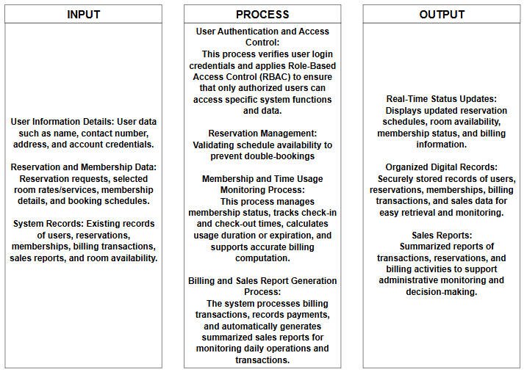

Figure 1. Conceptual Framework of Integrated Study Hub Management System

The conceptual framework of Integrated Study Hub Management System aims to automate manual workflows to improve efficiency, accuracy, and data security by ensuring that every transaction is properly secured and recorded. The inputs include customer or user information, service requests, and existing records such as reservation details, memberships, and user data. These inputs are processed through core system functions such as user authentication, reservation management, membership handling, time-based usage session tracking, billing, and sales report generation.
The process begins when a Student/Professional or an Admin/Staff logs into the system. The system validates credentials against the Users table and applies Role-Based Access Control (RBAC) to determine access permissions.

The reservation phase wherein the user or staff checks the availability of rooms or tables. After the verification, the reservation request is submitted, and the system will verify the availability to prevent double bookings. Once validated, the system updates the reservations table and sends a booking confirmation.

The Check in, upon physical arrival, the staff triggers a check-in, recording the time_in in the time logs. When the user leaves, the time_out is recorded, and the system calculates the total stay duration. At the end of the day, the system harvests all transaction data. Then, the system summarizes high-level metrics, including total_check_ins, total_logins, and total_time_logged into the Daily Reports table. The Admin reviews these reports to monitor daily performance and usage patterns.

Through these processes, the system ensures accurate scheduling, prevents double bookings, and efficiently manages transactions. The outputs generated include real-time status updates, well-organized records, and summarized sales reports on daily operations. Overall, the framework demonstrates how the proposed system converts raw data into useful information to enhance efficiency, accuracy, and decision-making within the study hub.

Chapter 3

3.1 Methodology

In this project, the proponents will focus on how the management, staff, and customers of WS Students & Professionals Lounge – La Paz Branch handle their daily operations to better understand their workflow. By combining different data gathering methods, the proponents will be able to collect useful and meaningful insights. These findings will help the proponents solve relevant issues such as manual reservation errors, difficulties in tracking memberships, and inaccuracies in billing and sales recording.

The proponents will conduct surveys and interviews to give them a better understanding of the manual tools the lounge currently uses to manage their data. This will also help the proponents see the bigger picture, such as how often issues like double bookings or stock discrepancies occur and how the staff feel about the current paper-based system. Based on these results, the proponents can gather data that will assist in creating an Integrated Study Hub Management System that specifically meets the needs of the WS Students & Professionals Lounge.

The surveys will be used to determine the frequency of operational problems and the difficulties faced by the staff during peak hours. This will help the proponents understand the user experience and the specific pain points of the current system. The collected data will provide a basis for the proponents to assess and provide solutions to the challenges and concerns faced by the lounge administrator and employees.

Furthermore, the proponents will also perform interviews and direct observations to better know the daily routine of the lounge’s staff. Knowing the challenges through face-to-face interactions will help the proponents identify necessary improvements in the reservations, memberships, and billing process. The combination of these research methods will allow the proponents to gather both quantitative and qualitative results, combining technical information with the personal experiences of the users to help design and create the proposed management system.

3.2 Methodology Table

METHODS | PARTICIPANTS | PURPOSE
Surveys | WS Students & Professionals Lounge Owner, General Manager, Staff, and Regular Customers | To gather quantitative data regarding the frequency of manual errors and the level of satisfaction with the current system.
Interviews | WS Students & Professionals Lounge Administrator and Employees | To obtain qualitative insights into the specific operational challenges, pain points, and desired features for the new system.
Observations | WS Students & Professionals Lounge Staff and Customers | To observe the actual workflow of reservation, membership management, time room usage, and billing to identify bottlenecks in the manual process.
Data Analysis | The Proponents | To synthesize the collected data, identifying patterns in operational errors, and correlating them with system requirements.
Solution Development | The Proponents | To design and develop the Integrated Study Hub Management System based on the analyzed needs and technical specifications.

Table 1. Methodology Table

3.3 Research and Development Stage

The Research and Development (R&D) stage is essential in guiding the Integrated Study Hub Management System from conceptualization to full implementation. This stage is dedicated to ensuring that the system specifically addresses the unique challenges of WS Students & Professionals Lounge. The process begins with extensive research to understand the current manual workflow and the frustrations of the staff regarding data integrity and customer service speed.

The proponents will analyze existing management systems to identify industry best practices while focusing on the specific needs of a study lounge environment. Through data-gathering methods such as surveys, interviews, and observations, the proponents will document the risks associated with the current manual setup, including issues in user registration, reservation handling, membership management, time-based room usage tracking (duration or expiration), billing, and sales report generation. This data will serve as the foundation for defining the functional requirements of the system.

After the data-gathering phase, the proponents will transition to the Design Stage. In this phase, the proponents will create the system’s architecture, focusing on key features such as user registration, reservation bookings, membership management, time-based room usage tracking (duration or expiration), billing, and sales report generation. The goal is to develop a user-friendly interface that simplifies the staff’s workload. Throughout this process, the proponents will use the initial feedback to ensure the design remains intuitive and responsive to the users’ needs.
Following the design, the proponents will proceed to the Development phase. This is where the actual coding and building of the system take place. The proponents will focus on creating a functional prototype that integrates the front-end interface with a secure back-end database. The development will be iterative, meaning the proponents will continuously refine the features based on preliminary internal testing to ensure the system is stable and efficient.

Once the prototype is fully developed, it will enter the Testing Phase. The system will undergo rigorous testing, including functionality testing, data integrity checks, and User Acceptance Testing (UAT). The proponents will involve the WS Students & Professionals Lounge staff to test the system in a controlled environment to ensure it can handle real-world scenarios like peak-hour bookings. Any bugs or vulnerabilities identified during this phase will be rectified before the final deployment.

Lastly, the R&D process concludes with Evaluation. The proponents will review the overall performance of the system against the initial objectives. By analyzing the final test results and user feedback, the proponents will confirm if the system effectively solves the identified problems of manual errors and tracking difficulties. Once all requirements are satisfied, the Integrated Study Hub Management System will be ready for full implementation, providing a secure and organized digital environment for the lounge.

3.4 Research Design

This study uses a developmental research design because the main goal of the proponents is to design and build a functional system that will solve the operational problems of WS Students & Professionals Lounge. The proponents will focus on creating a tool that is practical and can be used in the real-world setting of the business.

A descriptive approach is also used to help the proponents understand the current situation of the lounge. This involves looking into how the staff currently work, identifying the common problems they encounter, and knowing what specific features are needed for the new system. By describing the existing manual process, the proponents can better design a solution that fits the needs of the lounge administrator, staff, and customers.

3.5 System Development Methodology

The project follows the process of the System Development Life Cycle (SDLC) methodology, following these phases:

- Planning – In this phase, the proponents will identify the problems in the manual operations of WS Students & Professionals Lounge, such as reservation errors and the difficulty of tracking memberships. The proponents will also define the system requirements and scope to make sure the project addresses the issues in manual recording, inaccurate data handling, and the slow process of managing customer information.

- Analysis – The proponents will gather data through surveys, interviews, and direct observations with the administrators, staff, and customers of WS Students & Professionals Lounge. This includes analyzing the risks of using paper-based logs, such as data loss, double bookings, and the time-consuming process of manually checking and updating records, including reservation details and billing transactions.

- Design – The proponents will create a simple and user-friendly interface that is easy for the lounge staff to navigate. This phase also includes designing a database that can securely store customer information, membership records, reservation details, room rates/services, billing data, and sales reports to make data retrieval much faster.

- Implementation – The proponents will begin developing the system and setting up the necessary database. Key features will be implemented, including user registration, real-time reservation management, an automated membership tracker, time-based room usage monitoring (duration or expiration), billing, and sales report generation. Security features such as user login accounts and activity logs will also be included to make sure that the lounge data is protected and only authorized staff can access it.

- Testing – The proponents will check all the features of the system to make sure there are no bugs or errors. They will test if the registration, reservation, membership, billing, and sales report modules are working correctly. The staff of WS Students & Professionals Lounge will also be asked to try the system to see if it meets their expectations and if it is easy enough for them to use during their daily operations.

- Deployment – In this phase, the proponents will launch the system for actual use in the WS Students & Professionals Lounge. The proponents will also provide training for the employees to teach them how to use the system confidently and safely. The system will be monitored to ensure it runs smoothly, and the proponents will be ready to answer any questions from the staff to guarantee a good user experience.

3.6 Agile Development Methodology
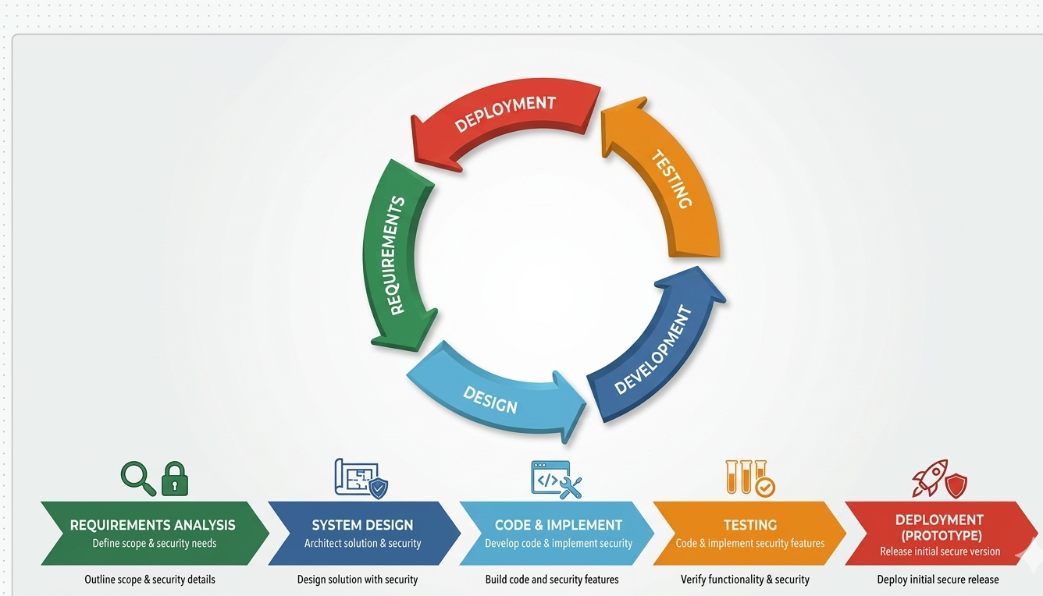

Figure 2. Agile Methodology

The Agile Methodology is chosen for the Integrated Study Hub Management System because the project aims to develop a secured, organized, and user-friendly system for the WS Students & Professionals Lounge. Agile is flexible and adaptable to changing requirements, which is important since the needs for managing user registration, reservations, membership tracking, time-based room usage, billing, and sales reporting may be refined during development. This methodology allows the proponents to receive continuous feedback and opinions from the lounge management, making sure that the final system effectively addresses their manual operational issues. It also promotes strong collaboration between the proponents and the client, ensuring that their expectations are met and all technical challenges are identified and resolved early.

In the Requirements Analysis phase, the proponents will gather detailed information about the current manual processes of the lounge. This includes identifying specific problems such as double bookings, manual inventory errors, and the difficulty of tracking membership durations. The proponents will define the system requirements and scope to ensure that the proposed system directly addresses the operational challenges of the lounge staff and administrator.

During the System Design phase, the proponents will plan and design the overall architecture of the system, including its features and layout. This involves creating a user-friendly interface for the reservation, membership management, and billing modules, as well as designing a robust database to securely store user information, membership details, reservation data, time-based room usage, and sales records securely. The design will focus on making the system intuitive for the staff to minimize the learning curve and ensure a smooth transition from paper-based processes to a digital system.

In the Development phase, which involves coding and implementation, the proponents will build the system based on the finalized design. The core features, such as user registration, real-time reservation management, automated membership tracking, time-based room usage monitoring (duration or expiration), billing and sales report generation, will be programmed and integrated. The proponents will ensure that the technology used is stable and capable of handling multiple transactions simultaneously without having data errors or system delays.

For the Testing phase, the proponents will conduct rigorous evaluation to ensure that the system functions properly and is free from critical errors. This includes verifying the accuracy of billing calculations, the reliability of reservation management, and the effectiveness of the preventing scheduling conflicts feature. The staff and administrator of WS Students & Professionals Lounge will also be invited to test the system prototype to determine whether it meets their requirements and to identify any necessary improvements before final implementation.

Lastly, in the Deployment phase, the proponents will present the system as a fully functional prototype for the WS Students & Professionals Lounge. This includes conducting a basic orientation or training session for the staff to ensure they know how to use the system effectively and confidently. The proponents will also monitor the initial usage of the system to guarantee a smooth user experience and gather final feedback to ensure that the system is fully ready for the lounge’s daily operations.

3.7 Data Collection Techniques

To create and design the Integrated Study Hub Management System that truly meets the needs of the management, staff, and customers of WS Students & Professionals Lounge, the proponents will gather important data and insights using different techniques and methods. These techniques will help the proponents ensure that the system is user-friendly, efficient, and aligned with the problems and issues that need to be solved.

1. Surveys

The proponents will distribute surveys to the target users, including the lounge owner, general manager, staff, and employees. These surveys will help the proponents understand how they currently handle reservations, membership management, billing transactions, and sales reports, as well as the common problems they encounter and their expectations for a more organized digital system. The survey questions will also cover usability, system efficiency, and preferred features, which will guide the proponents in further development of the system.

2. Interviews

The proponents will conduct one-on-one interviews with the lounge administrator and selected staff members who are involved in managing daily operations, including reservations, billing, and record-keeping. This will allow the proponents to gain a deeper understanding of the challenges faced by the lounge in more detail—information that a simple survey might not provide. The proponents will ask the interviewees to share their personal experiences, concerns, and ideas on how to improve the efficiency and reliability of the reservation, billing, and management processes.

3. Focus Groups

The proponents will also organize a small group discussion with the lounge staff and manager to further discuss the proposed management system. This discussion will allow each participant to share their opinions, suggestions, and concerns regarding the planned features. By doing this, the proponents can identify which concerns are the most important and prioritize which features should be developed first to better meet the user’s needs.

4. Observations

To better understand the daily workflow, the proponents will conduct direct observations of the existing manual processes being used in the lounge. This includes monitoring how the users' or members' information is recorded, how reservations are made, how the availability of study pods is checked, how the time duration/expiration of every customer is used, how the billing is transacted, and how the sales report is tracked. This will help the proponents spot the exact parts of the process where delays and errors usually happen.

5. Document Analysis

The proponents will also review existing records, logs, and articles related to study hub management and POS (Point of Sale) systems. This includes examining past reservation logs, billing records, sales report lists, and relevant studies on automated management systems. Through this analysis, the proponents will gain a clearer understanding of current practices and identify best practices that can be applied in developing a system tailored specifically to the needs of the WS Students & Professionals Lounge.

3.8 System Architecture and Design

Overview

The Integrated Study Hub Management System is designed to make the daily operations of WS Students & Professionals Lounge more organized, efficient, and digital-friendly. The system is built to solve the problems of manual recording, double bookings, and the hard way of tracking memberships and sales reports. By moving from a paper-based system to a digital one, the lounge can ensure that all data is kept in a safe and organized place, making it easier for the staff to manage the hub and for the customers to enjoy the services.

The system supports different types of users, specifically the Admin, Staff, and Customers, each having their own roles and duties. The Admin has full control, such as managing user accounts and reservations, viewing detailed sales reports, and tracking the overall operations of the lounge. The Staff can handle the real-time reservations, process users or members information details, check room availability status, and billing transactions. Meanwhile, the Customers can easily view available study pods and manage their reservations or bookings. This organized flow ensures that the lounge’s operation is smooth and that errors are avoided.

3.9 System Architecture

The Integrated Study Hub Management System will be developed using a Three-Tier Architecture to ensure a structured, scalable, and organized flow of data. This architecture consists of the following three layers:

- Presentation Layer – This layer provides the user interface (UI) where administrators, staff, and customers can interact with the system. It features a responsive dashboard for user registration, monitoring room occupancy, making reservations, and processing membership. For the administrator and staff, it includes management panels for handling users, reservations, memberships, transaction records, and real-time sales reporting. This layer also uses Role-Based Access Control (RBAC) to ensure that the interface and menus are customized based on the user’s role—restricting sensitive management functions to authorized personnel while providing a simple, user-friendly interface for customers to register, make reservations, and view relevant account or billing information.

- Application or Logic Layer – This serves as the "brain" of the system that handles all user requests and processes the core business logic. It includes the User Management module for handling user registration and authentication, the Reservation Module that checks for room availability and prevents double bookings, the Membership Module that manages membership status, calculates usage duration, and subscription validity, the Billing Module that processes and calculates payments accurately, and the Sales Report Module that generates transaction summaries. This layer ensures that all operations are validated and correctly processed before sending or retrieving data from the database and returning results to the presentation layer.

- Database Layer – This layer is responsible for the secure and organized storage of all essential information using MySQL. It stores user profiles, membership records, transaction logs, room schedules, billing transactions, and sales reports. The database layer ensures data integrity, consistency, and security, making sure that every transaction and system activity is recorded accurately. It also allows fast and reliable data retrieval for real-time processing, reporting, and auditing purposes.

3.9.1 System Architecture Diagram

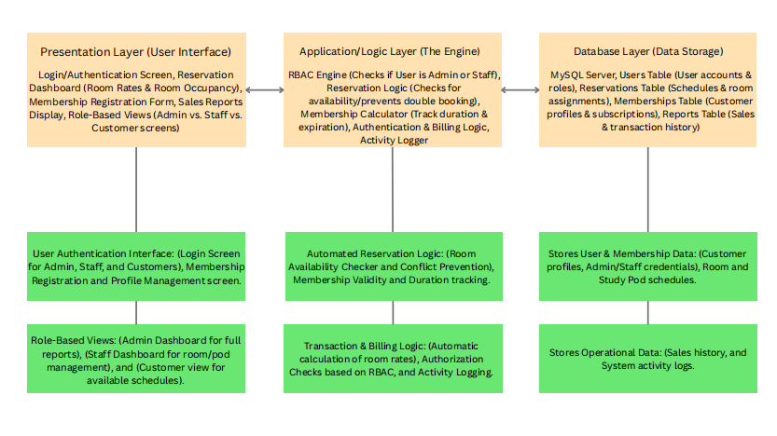

System Architecture Diagram

Figure 3. System Architecture Diagram of Integrated Study Hub Management System

3.10 System Components and Modules

The Integrated Study Hub Management System is made up of different modules that work together to create a simple and organized management tool. It uses automated tracking and role-based access to make sure that the operations are smooth and secured from errors or unauthorized access.

User Management Module
This manages the login and profiles of the admin, staff, and customers. Its key features include secure login for different user levels, profile management for members, and password management to keep accounts safe. It also handles session management to make sure that only authorized staff can access the management dashboard.

Reservation and Booking Module
This is the core module for managing study pods and rooms. Its key features include a real-time availability checker to avoid double bookings, a walk-in/reservation form for customers and staff, and a schedule monitor that shows which rooms are occupied or vacant. It also tracks the time duration of stay to help the staff manage the turnaround of customers.

Membership and Subscription Module
This module handles the records of regular members of the lounge. Its key features include a registration system for new members, tracking of membership expiration dates, and a history of their visits. It helps the management identify loyal customers and manage special discounts or membership perks.

Sales and Reports Module
This provides the tools to manage the sales, transaction history, and other supplies in the lounge. Its key features include an automated sales and tracker that records every transaction. This ensures that the inventory is always accurate and easy to audit.

Admin Dashboard and Reporting Module
This provides the administrator with a centralized tool to see the overall status of the business. Its key features include viewing sales reports (daily, weekly, or monthly), monitoring user activities, and managing the list of room rates. It also provides analytics on peak hours to help the manager decide on staffing needs.

Notification and Alert Module
This module helps in communicating important updates to the staff and customers. Its key features include alerts for successful bookings, notifications when a customer’s time is almost up, and system alerts if there are issues with the data records.

Security and Access Control Module
This part includes all the key security features of the Integrated Study Hub Management System:

- Use password encryption to protect the login details of the admin, staff, and customers.
- Implements Role-Based Access Control (RBAC) so that staff can only access the user’s or members’ details, reservation bookings, and billing while the admin can access the sensitive sales reports.
- Ensures that all reservation and membership data are backed up and safe from being lost or deleted.
- Protects the customer information from unauthorized access or data breaches.

3.11 System Architecture and Design

3.11.1 Context Diagram

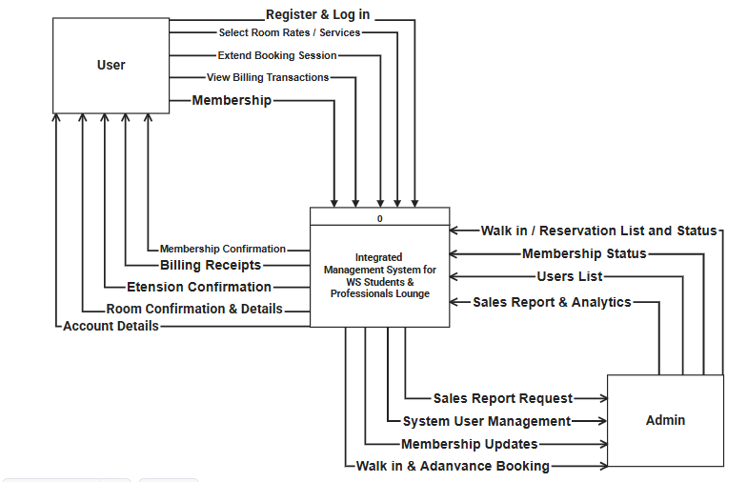
Figure 4. Context Diagram of Integrated Study Hub Management System

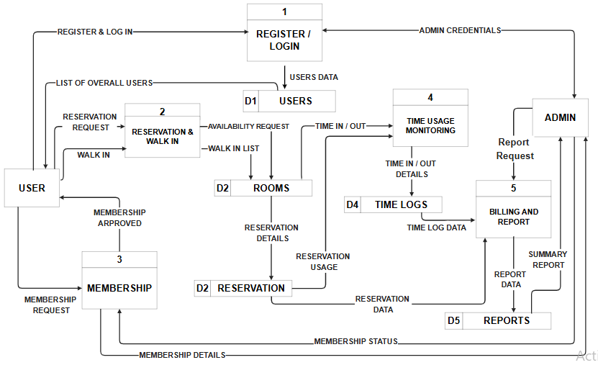

Figure 5. Data Flow Diagram of Integrated Study Hub Management System

Significance of Context and Data Flow Diagram

The hierarchical structure of the context diagram and the Data Flow Diagrams (DFDs) provides a detailed blueprint of the Integrated Study Hub Management System (WS Lounge). It outlines the flow of information from the conceptual overview down to the specific operational processes, ensuring that every transaction—from room bookings to sales report updates—is properly tracked and organized.
As shown in Figure 4. Context Diagram, the system’s scope is established by outlining the primary interactions between the external entities and the core system. The User initiates the flow by submitting registration requests, login credentials, room booking reservations, and requests to extend booking sessions. In return, the system provides confirmations, room details, and billing receipts. Simultaneously, the Admin interacts with the system by managing room rates, monitoring customer walk-ins, and performing system user management. The Admin also receives critical outputs such as sales reports and analytics through this centralized flow.
Moving to the Level 1 DFD, these high-level interactions are decomposed into five discrete sub-functions: Register/Login, Reservation & Walk-in, Membership, Time Usage Monitoring, and Billing and Report. For example, when a user makes a reservation, the system checks for availability against the Rooms (D2) data store. The Time Usage Monitoring process tracks "Time In/Out" details, which are then recorded in the Time Logs (D4) to ensure accurate duration tracking.
The Level 2 and Level 3 DFDs provide the most detailed view of the system's internal actions, such as the automatic calculation of total billing based on the data retrieved from time logs and reservation usage. This detailed modeling approach helps in design validation and ensures that all technical and operational requirements of the WS Students & Professionals Lounge are met, providing a smooth and error-free experience for everyone.

3.11 Use-Case Diagram

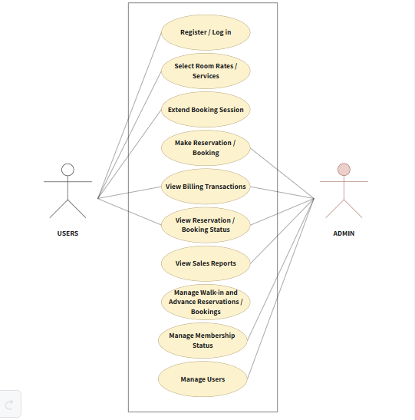

Figure 6. Use-Case Diagram of Integrated Study Hub Management System

Significance of Use-Case Diagram

The Use Case Diagram for the Integrated Study Hub Management System is essential as it illustrates the dynamic behavior of the platform by defining the interactions between the users and the various functions of the system. It establishes a structured and secure approach to lounge management by mapping out the specific tasks that the two primary actors—the User (Students/Professionals) and the Admin (Staff/Management)—can perform within the system's boundary. It presents the main functions available within the system and shows how each actor interacts with these features to support the daily operations of WS Students & Professionals Lounge. By defining these interactions, the diagram helps ensure that all system requirements are clearly identified and properly organized according to user roles and responsibilities.
From the users’ perspective, the system provides a simple and user-friendly process for accessing study hub services. Users can Register/Log In, Select Room Rates/Services, Make Reservations/Bookings, Extend Booking Sessions, View Reservation/Booking Status, and View Billing Transactions. These functions allow users to conveniently manage their reservations and monitor their transactions within the system. The diagram emphasizes a streamlined booking experience that reduces manual processing and improves accessibility for customers.
For the administrators and staff, the system provides management and monitoring capabilities necessary for daily operations. Admins can manage reservations, oversee membership status, handle walk-in and advance bookings, manage user accounts, and monitor billing and sales reports. Through the View Sales Reports feature, administrators can review summarized transaction records to support operational monitoring and decision-making.
Overall, the Use-Case Diagram demonstrates how the proposed system supports efficient reservation management, organized user handling, accurate billing, and sales monitoring. It also highlights the role-based structure of the system, ensuring that each actor is provided with appropriate access and functions to maintain security, efficiency, and effective study hub management.

3.12 Entity Relationship Diagram (ERD)
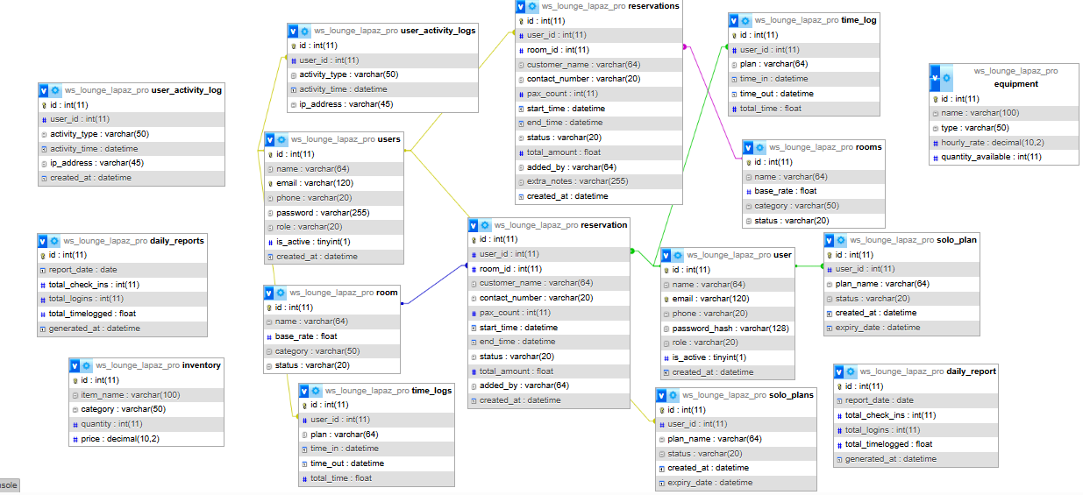

Figure 7. Entity Relationship Diagram of Integrated Study Hub Management System

Significance of Entity Relationship Diagram

The Entity-Relationship Diagram (ERD) for the Integrated Study Hub Management System is significant because it provides a precise blueprint of the entire system's data management structure. It begins by defining the core data requirements, establishing essential entities like users, reservations, and sales reports as the primary objects the system must manage. The ERD uses lines and cardinality to establish clear rules and relationships that control how these entities interact, which prevents data inconsistency. This diagram serves as a Database Design Map, as each entity directly translates into database tables, with defined attributes becoming the primary keys to ensure data integrity. Furthermore, it creates clear communication and validation among the proponents, making sure the way bookings and sales reports are managed aligns perfectly with the lounge's operational needs.

3.13 Database Design

The database of the Integrated Study Hub Management System was designed to store, manage, organize, and secure all data related to the lounge’s operations, including user information, booking reservations, and sales reports. It follows a relational database model where tables are primarily linked through Primary Keys (PK) and Foreign Keys (FK) to ensure that information remains accurate and synchronized at all times.

Main Tables / Entities

- Users
  - Includes all individuals who interact with the system, such as the Admin, Staff, and Customers.
  - Attributes include: id_user (PK), username, password, name, role, contact, created_at.
  - The primary account table that stores login credentials, system roles, and audit trail information for every individual accessing the lounge services.

- Reservations (Bookings)
  - Stores all data related to room reservations made by the users.
  - Attributes include: id_reservation (PK), id_user (FK), id_room (FK), start_time, end_time, status, total_amount.
  - This table tracks the schedule and occupancy of the study hub to prevent double bookings and manage user time slots effectively.

- Rooms
  - Represents the specific areas, study pods, or rooms available for booking within the lounge.
  - Attributes include: id_room (PK), name, base_rate, category, status.
  - This metadata registry stores information for each study area, including pricing and current availability status.
- Time Logs
  - Tracks the actual check-in and check-out times of the users for billing and monitoring.
  - Attributes include: id_log (PK), id_user (FK), time_in, time_out, current_plan.
  - An audit trail used for calculating the actual duration of a user’s stay and ensuring accurate billing.

- Daily Reports
  - Stores summarized data for administrative monitoring and business decision-making.
  - Attributes include: id_report (PK), report_date, total_check_ins, total_logins, total_time_logged.
  - A management table that provides high-level insights into the lounge's daily performance and usage patterns.

3.14 User Interface Design
Put picture here
Landing Page
Admin Dashboard
Reservation Bookings

Reservations List
Membership Page

Report History

User Dashboard

Time Logs
Reservation Page
Membership Plans

The Integrated Study Hub Management System is composed of several interconnected modules designed to streamline the operations of the WS Students & Professionals Lounge. These components work in harmony to ensure data integrity, security, and a seamless user experience. The system includes the following interfaces:

- Landing Page: The digital gateway to the Integrated Study Hub Management System, designed to guide users toward their specific needs—whether they are customers looking for a space or staff members managing operations. It prioritizes clarity and immediate access to core functions.

- Admin Dashboard: The central command center for the Integrated Study Hub Management System, providing the branch general manager or owner with total visibility over the lounge's operations. It shifts from the transactional focus of the user to a high-level oversight of financial and operational health.

- Reservation Bookings: The system's primary scheduler, designed to manage the lifecycle of a study session from the initial request to the physical check-in. It ensures that the WS Students & Professionals Lounge operates at peak efficiency by organizing space allocation and preventing scheduling conflicts.

- Reservations List: The core operational tool used by both Staff and Admin to monitor, verify, and manage all scheduled bookings within the hub. It acts as the "master schedule" that ensures the physical lounge areas are organized and utilized efficiently.

- Membership Page: The central hub for users to manage their long-term relationship with the lounge. It transitions the user from a one-time visitor to a recurring member, offering structured access to the lounge’s premium study environments and professional services.

- Report History: The system’s permanent archive, allowing the Admin to look back at past performance to identify long-term trends and seasonal patterns. While Daily Reports focus on the immediate "now," the Report History provides the "big picture" necessary for longitudinal business analysis.

- User Dashboard: This serves as the primary interface for Students and Professionals, providing a real-time overview of their interactions with the Integrated Study Hub Management System. It is designed to streamline the user experience by consolidating personal activity, financial data, and resource access into a single view.

- Time Logs: The primary mechanism for tracking the physical presence and duration of stay for every student and professional in the lounge. It serves as the bridge between a reservation and the final billing process.

- Reservation Page: The interactive interface where students and professionals secure their workspace. It is designed to be intuitive, ensuring that the process of booking a study area is fast, transparent, and error-free.

- Membership Plans: Represent a tiered subscription model designed to provide consistent value for frequent visitors of the WS Students & Professionals Lounge. By categorizing users into specific plans, the system can automate pricing and access privileges according to the selected tier.

- Role-Based Access Control - All actions and file access within the system must be governed by a strict RBAC. This makes sure that the users can only access limitedly based on their given roles.

Technology Stack

For the development of Integrated Study Hub Management System of WS Students & Professionals Lounge, the proponents use these different programming languages, hardware, software, frameworks, libraries, databases, and different hardware and software tools. The proponents manage the system's security, user-friendly, simple design, performance, and its effectiveness. Below is a more detailed description of the proponents used in creating and designing their system:

3.15 Programming Languages and Tools Used:

Programming Languages | Used For
Python | For the main backend language.
SQL | For database queries and schema definition.
HTML/CSS | For frontend templating and styling.
JavaScript | For client-side functionality and interactivity.

Table 2. Programming Languages of Integrated Study Hub Management System of WS Students & Professionals Lounge

3.15.1 Backend Frameworks and Libraries:

Backend Frameworks and Library | Purpose or Used for
Flask | The primary web framework is used for routing and request handling.
Flask-SQLAlchemy | Used as an ORM to manage database models and execute queries easily.
Flask-Login | Manages user sessions and authentication for Admin and Staff access.
Flask-WTF / WTForms | Handles secure form processing and provides CSRF protection.
Bcrypt | Used for secure password hashing to protect user credentials.
Flask-SocketIO | Enables real-time, bidirectional communication for live dashboard updates.
MySQL-connector-python | The official driver used to connect the Flask app to the MySQL database.
Flask-Mail | Used for sending automated email notifications to users or administrators.
ReportLab | A library used for generating PDF files and operational reports.
Stripe | Integrated for secure online payment processing for lounge services.
Alembic | Used for database migrations to track changes in the DB schema.
Python-dotenv | Loads environment variables from a .env file for security and configuration.
Werkzeug | Provides WSGI utility functions for the Flask application stack.
Email-validator | Ensures that user-provided email addresses are in the correct format.
Gunicorn | A production-grade WSGI HTTP server used for deploying the application.
Pytest | The framework used for running automated tests to ensure system stability.
Black | A PEP 8 compliant code formatter used to maintain clean and consistent code.

Table 3. Backend Frameworks and Libraries Integrated Study Hub Management System of WS Students & Professionals Lounge

3.15.2 Front-End Frameworks and Libraries:

Front-end Frameworks and Library | Purpose or Used for
Vanilla HTML / CSS | Used for the core structure and custom styling of the user interface.
Vanilla JavaScript | Handles client-side interactivity and application logic.
Font Awesome (via CDN) | Provides the icon library used throughout the system’s UI.
Google Fonts (Inter) | The primary typography used for a clean and professional look.
Chart.js (via CDN) | Used for creating visual charts and data visualizations for reports.
Socket.IO (Client) | Handles real-time notifications and live updates on the dashboard.
Icons8 | Source of external decorative icons for the system’s statistics and menus.
Moqups | Used for creating wireframes and initial UI designs of the system.
Canva | Used for designing graphic assets, presentations, and branding elements.
Favicon | Used to provide a small, iconic image for the browser tab of the system.

Table 4. Front-End Frameworks and Libraries of Integrated Study Hub Management System of WS Students & Professionals Lounge

3.15.3 Software Tools

- Visual Studio Code – The primary source code editor used for writing and managing the system’s code.
- GitHub – For version control and collaborative management of the project's source code.
- Figma / Canva / Moqups – Used for creating diagrams, flowcharts, and the final presentation.
- XAMPP / MySQL Workbench – For managing the local database and testing queries.

3.15.4 Software Specifications

- Database: MySQL 8.0 (or MariaDB)
- Python Version: 3.10
- Web Framework: Flask 2.x

3.15.5 Hardware Specifications

- Processor: Intel(R) Celeron(R) CPU 3867U @ 1.80GHz (1.80 GHz)
- RAM: 8.00 GB
- Storage: 119 GB

3.15.6 Minimum Hardware Requirements for User (Client)

- Device: Any smartphone, tablet, laptop, or PC with an active internet connection.
- Browser: Google Chrome, Mozilla Firefox, or Microsoft Edge.

3.15.7 Software Requirements
- Operating System: Windows 11 Pro, 64-bit os
- Python: 3.8+ version.
- Database Drivers: MySQL Connector for Python.

3.16 Survey Questions for System Assessment

This survey aims to assess the user requirements and expectations for the "Integrated Study Hub Management System." The data gathered will help the proponents address the general operational challenges within the current manual setup of WS Students & Professionals Lounge. Your honest feedback is essential in developing a more streamlined and effective management solution. All responses will be handled with strict confidentiality.

Demographic Information

1. What is your role in WS Students & Professionals Lounge?
- Manager / Owner
- Staff / Employee
- Regular Customer (Student/Professional)
- Occasional Visitor
If other (Please Specify): ____________

2. How long have you been using study hubs or similar lounge facilities?
- Less than 1 year
- 1-2 years
- 3-4 years
- 5-6 years
- More than 6 years

3. What type of user are you?
- Student
- Professional / Freelancer
- Occasional Visitor

4. What method do you currently use for lounge reservations?
- Walk-in / Face-to-face
- Social Media (Messenger/Instagram)
- Phone Call / Text
If other (Please Specify): ____________

5. How satisfied are you with the current reservation/booking method you are using?
- Very Satisfied
- Satisfied
- Neutral
- Not Satisfied
- Very Not Satisfied

6. What operational challenges do you face with the current manual system? (Select all that apply)
- Double Bookings
- Inaccurate Time Tracking
- Lack of Real-time Availability
- Slow Billing Process
If other (Please Specify): ____________

7. How would you rate the overall quality of the current lounge management process?
- Very High
- High
- Average
- Low
- Very Low
8. How satisfied are you with the current security and privacy of your records/data?
- Very Satisfied
- Satisfied
- Neutral
- Not Satisfied
- Very Not Satisfied

9. How satisfied are you with the speed of confirming your booking?
- Very Satisfied
- Satisfied
- Neutral
- Not Satisfied
- Very Not Satisfied

10. How satisfied are you with the design or user interface (UI) of the current manual setup?
- Very Satisfied
- Satisfied
- Neutral
- Not Satisfied
- Very Not Satisfied

11. How would you rate the support and service provided for your lounge concerns?
- Very Good
- Good
- Neutral
- Poor
- Very Poor

12. How frequently do you encounter issues like records being lost or incorrect time logs?
- Never
- Rarely
- Sometimes
- Frequent
- Always

13. How many times do you visit or book the lounge per month?
- Less than 5
- 5-10
- 11-20
- 21-30
- More than 30

14. What is your average duration of stay in the lounge?
- Less than 2 hours
- 2-5 hours
- 6-8 hours
- Whole day
- More than a day (Membership)

15. How satisfied are you with the current notification system for your bookings?
- Very Satisfied
- Satisfied
- Neutral
- Not Satisfied
- Very Not Satisfied

16. What type of services do you frequently avail in the lounge?
- Private Study Pods
- Group Meeting Rooms
- Common Area
- Food & Beverage Services
If other (Please Specify): ________________

17. What security features do you prefer for your system account? (Select all that apply)
- Strong Password Policy
- Role-Based Access
- Login Notifications
- Secure Transaction History

18. What type of transaction method have you been using?
- Face-to-face (Manual)
- Online Booking
- Phone-based Reservation
- Walk-in
19. What type of information do you usually share with the lounge?
- Contact Details
- Identification (Student/Professional ID)
- Payment Information
- Schedule/Preferences

20. Who do you usually interact with for your lounge needs?
- Owner
- Lounge Manager
- Front Desk Staff
- Security Personnel

3.17 Sampling Methods for Respondents

To ensure a balanced and comprehensive evaluation of the system, the researchers will implement a stratified sampling technique. This approach guarantees that the diverse user base of WS Students & Professionals Lounge—from the daily customers to the administrative personnel—is accurately represented in the data collection process. The following steps outline the execution of this strategy:
- Define Strata: Participants will be divided into specific subgroups based on their interaction with the lounge. These groups consist of Students, Professionals/Freelancers, Visitors, Frontline Staff, and Business Management. Segmenting the respondents this way allows the proponents to analyze distinct user requirements and operational pain points from various viewpoints.

- Sampling Within Strata: A random selection process will be applied within each group to maintain objectivity. For the guest categories (Students and Professionals), the proponents will invite respondents during peak and off-peak hours to gather a wide range of feedback. For the organizational side, the study will involve the actual employees and managers currently handling the lounge’s daily transactions.

- Target Sample Size: The proponents intend to secure a minimum of 30 to 50 completed surveys. This sample size is sufficient to identify recurring operational themes and provide a reliable basis for the system’s design and feature validation.

- Survey Distribution: The assessment will be conducted through a hybrid approach. An online version of the survey will be deployed via Google Forms, accessible through social media and email. Simultaneously, the researchers will facilitate on-site data gathering using printed questionnaires and tablets for walk-in clients. To ensure maximum participation, the digital survey is optimized for all major platforms, including Android, iOS, and Windows, allowing for seamless access regardless of the respondent's device.

3.18 Data Analysis Techniques

To determine the efficiency and user-responsiveness of the Integrated Study Hub Management System, the researchers will apply a dual approach of quantitative and qualitative data analysis. This framework allows for the conversion of raw information—collected through structured surveys, stakeholder interviews, and technical system logs—into comprehensive findings that evaluate the software’s performance and operational impact.
The study will utilize Descriptive Statistics to provide a clear summary of the data, such as identifying the proportion of clients who are satisfied with the existing manual transactions versus those who encounter operational bottlenecks. This method helps the proponents quantify user experiences, such as the frequency of booking errors or the number of hours typically spent by users in the hub.
Furthermore, Cross-tabulation will be used to analyze the correlation between different user demographics, such as comparing the specific requirements and satisfaction ratings of Students against those of Working Professionals. To establish a standard for user feedback, the Mean, Median, and Mode will be calculated, providing an average score for the system’s usability and functionality. To enhance the clarity of the report, the proponents will present these findings through visual tools like Bar Graphs and Pie Charts, enabling a straightforward comparison of trends between the lounge’s previous manual operations and the newly implemented digital solution.

3.19 Methods for Processing Raw Data

To uphold the accuracy and reliability of the research findings, a systematic protocol for handling raw data will be strictly followed before any formal analysis occurs. Once information is gathered through surveys, client interviews, and operational observations, it will undergo a multi-stage processing phase to ensure data integrity and readiness for interpretation.

- Data Scrubbing and Auditing: The initial stage involves a thorough review of the collected survey responses to identify any gaps, such as incomplete forms or duplicate entries. Any submissions that contain significant errors or inconsistencies will be isolated or excluded to maintain the quality of the dataset.

- Systematic Coding: After scrubbing, a coding system will be implemented for both quantitative ratings and open-ended feedback. This involves assigning specific numerical or thematic labels to responses, allowing for a more structured and streamlined classification during the analysis phase.

- Data Tabulation and Management: The researchers will then organize the coded data by migrating it into centralized spreadsheets. This structured format ensures that the information is easily accessible for statistical computation and cross-referencing.

- Verification and Validation: A validation check will be performed to confirm that the digitized data accurately reflects the original input from the participants. This step is crucial to prevent any clerical errors during the manual encoding process.

- Final Synthesis and Preparation: In the final stage, the data will be summarized and formatted into tables or charts. This prepares the findings for a comprehensive evaluation against the system’s development goals and user requirements.

3.20 Frameworks for Evaluating System Effectiveness

To ensure that the Integrated Study Hub Management System aligns with the technical requirements and user expectations of the WS Students & Professionals Lounge, the proponents will adopt established evaluation frameworks. These models provide a structured criteria for assessing the platform’s performance, security, and overall user acceptance.
The study will utilize the ISO/IEC 25010 Software Quality Model as the primary standard for technical evaluation. This framework allows the researchers to measure the system’s quality through key characteristics such as Functional Suitability, Performance Efficiency, Compatibility, Usability, Security, Maintainability, and Portability. By applying this model, the proponents can verify if the system effectively executes its core tasks, operates reliably under varying user loads, and remains compatible with the various hardware and software environments used in the hub.
Furthermore, the Technology Acceptance Model (TAM) will be implemented to gauge the adoption readiness of both the staff and the customers. Through the analysis of user feedback, the proponents will evaluate the Perceived Usefulness (PU) and Perceived Ease of Use (PEOU) of the system. This assessment will determine if the participants believe the system simplifies the lounge’s transaction flow and if the interface is intuitive enough for daily operation.

The proponents are committed to maintaining transparency and high ethical standards throughout the research and development lifecycle. To ensure the protection of all participants, the following protocols will be observed:
- Voluntary Participation: The researchers will strictly avoid any form of coercion or exploitation. Participants will be fully informed of the study's nature and can choose to withdraw at any time.

- Academic and Professional Approval: Ethical clearance will be sought from the academic review board and the lounge management before the commencement of data gathering to ensure compliance with institutional standards.

- Confidentiality and Respect: All contributions from the respondents will be handled with the utmost respect. Personal data will be anonymized, and the findings will be reported with full integrity, ensuring no manipulation or misrepresentation of results.

- Accountability in Development: The final system is designed to promote a secure and accountable environment, ensuring that the lounge's operational data is handled responsibly and that the software fosters trust among its users.

3.21 Ethical Considerations

The proponents are committed to upholding the highest standards of research ethics throughout the development and implementation of the Integrated Study Hub Management System. The following ethical principles will serve as the foundation of the study:
- Commitment to Data Privacy
  - Implementing secure authentication measures to ensure that sensitive lounge records and personal information are only accessible to authorized personnel.
  - Safeguarding user information against unauthorized access, potential data breaches, and accidental leaks.

- System Integrity and Security
  - Applying robust data protection protocols to maintain the confidentiality and accuracy of all financial and operational records.
  - Conducting regular system evaluations to identify and address vulnerabilities, ensuring a safe digital environment for the lounge’s transactions.

- Informed Consent and Transparency
  - Providing clear information regarding the system’s functions and data usage policies before users engage with the platform.
  - Ensuring that respondents and system users are fully aware of how their activity logs and personal data will be managed and stored.

- Prevention of System Misuse
  - Integrating accountability features, such as transaction logs and role-based permissions, to discourage the fraudulent use of the system.
  - Ensuring that the management tools are used strictly for professional and operational purposes within the lounge.

- Inclusivity and Universal Access
  - Designing an intuitive user interface that is accessible to all students and professionals, regardless of their level of technical expertise.
  - Ensuring the system remains fair and unbiased in its automated pricing and membership features.

- Compliance with Regulatory Standards
  - Strict adherence to the Data Privacy Act of 2012 (Republic Act No. 10173) of the Philippines to ensure legal compliance in handling sensitive information.
  - Maintaining ethical standards in data management and administrative reporting.

- Professional and Ethical Responsibility
  - Demonstrating a commitment to objective and responsible decision-making at every stage of the software development life cycle.
  - Prioritizing the welfare of the lounge’s stakeholders through transparent operations and reliable system performance.

Chapter IV

Result and Interpretation

This chapter presents the data gathered, analyzed, and interpreted during the development, implementation, and evaluation phases of the Integrated Study Hub Management System. It highlights the key findings and evaluates the system’s effectiveness in achieving its core objectives, specifically in automating transaction flows, implementing Role-Based Access Control (RBAC), and resolving the operational bottlenecks at the WS Students & Professionals Lounge.
The presented outcomes are derived from comprehensive system performance evaluations, User Acceptance Testing (UAT), and operational workflow assessments conducted during the system's deployment. Ultimately, this chapter demonstrates how the newly developed platform addresses the logistical vulnerabilities and administrative challenges identified in the earlier parts of the study, thereby validating the proponents' goal of establishing a streamlined, accurate, and efficient management solution for the study hub.

Task Manager:

Gantt Chart / Project Timetable

Week | Task | Programmer | UI/UX Designer | Documenter
Week 1 | Project Planning & Requirements Gathering | Defined the technical stack and system requirements. | Conducted user interviews and established the customer journey map. | Conducted user interviews; Created initial drafts of Chapters 1 and 3.
Week 2-3 | Research & System Architecture Planning | Finalized the backend framework and determined the database logic data flow. | Researched best practices for lounge booking interfaces and planned wireframes. | Completed the literature review for Chapter 2.
Week 2-3 | Agile Framework Development | Assisted in mapping out sprint cycles. | Assisted in defining user stories for the hub. | Created and structured the Agile Scrum Framework documentation.
Week 4-5 | Use Case Diagram | Assisted in technical scoping. | Contributed to user role definitions. | Developed the system's Use Case Diagram.
Week 4-5 | Data Flow Diagram | Mapped the data input/output routes. | Assisted in workflow visualization. | Formulated the system's Data Flow Diagram (DFD).
Week 4-5 | Entity Relationship Diagram | Designed the Entity Relationship Diagram (ERD) for data optimization. | Formulated user interface schema dependencies. | Documented the ERD and detailed the specific data attributes.
Week 6-7 | Database Design & Schema Creation | Developed the final database schema, including tables for Users, Reservations, Memberships, and Time Logs. | Reviewed data input field structures for the UI. | Documented the Database Design and created the necessary table specifications.
Week 8-10 | UI Wireframes and Mockups | Reviewed technical feasibility of the layouts. | Developed and finalized interactive mockups for the Landing Page, Dashboards, and Booking Page. | Assisted in organizing visual design documentation.
Week 10-12 | Frontend Development | Began developing core system logic and API connection points. | Implemented approved UI mockups using HTML, CSS (Bootstrap), and JavaScript. | Documented the frontend architecture and user interface manual.
Week 12-16 | Backend Development | Coded backend system architecture, including RBAC engines, reservation logics, and automated billing. | Refined components to match backend data responses. | Tracked development milestones and compiled technical notes.
Week 16-18 | Integration of Frontend and Backend | Integrated backend APIs with the interactive frontend modules. | Coordinated with the programmer to adjust responsive layouts. | Documented integration test cases and data flows.
Week 18-19 | System Security Testing & Debugging | Debugged backend logic and validated transaction processing data. | Patched responsive UI/UX flaws and navigation bugs. | Logged active test cases, system errors, and resolution results.
Week 20 | System Evaluation | Optimized database response times and query speeds. | Implemented aesthetic refinements based on initial user feedback. | Summarized evaluation outcomes and final performance metrics.
Week 21-22 | Documentation Finalization | Reviewed technical descriptions in the paper. | Finalized system figures, diagrams, and captions. | Compiled and completed the Final Research Documentation.
Week 23-24 | Presentation and Submission | Set up the backend environment for live demonstration. | Polished the client-side presentation interface. | Formulated the presentation structure and finalized all project deliverables.

Table 5. Gantt Chart of Integrated Study Hub Management System of WS Students & Professional Lounge

Presentation of Results
The development of the Integrated Study Hub Management System was driven by the necessity to transition WS Students & Professionals Lounge into a fully digitalized environment, optimizing how user interactions and workspace assets are administered. To validate its efficacy, the software underwent a series of technical evaluations that tested its resilience against common operational friction. The engineering of the platform emphasizes data governance through a structured user hierarchy, ensuring that administrative privileges are securely partitioned.
During the operational trials, the application was subjected to stress testing to observe its stability in managing synchronous reservation inputs, logging actual client check-ins without database lag, and ensuring that time-dependent fee calculations remain accurate. Furthermore, a usercentric assessment was executed involving active front-desk operators, business managers, and daily clients. These participants navigated through the client portal, validated the automated billing adjustments for varying membership statuses, and audited the generation of financial history sheets. The empirical feedback gathered from these assessments demonstrated that the application completely eradicates the operational risks of overlapping schedules and manual calculation errors, successfully achieving the project’s benchmark for institutional modernization.

Impact of Integrated Study Hub Management System of WS Students & Professionals Lounge on the Information Technology Field
The architecture of this project offers an architectural case study in the field of localized corporate automation and specialized database management. It confronts a prevalent challenge in small-scale hospitality and co-working sectors: the deployment of a centralized transaction framework that balances client data integrity with dynamic, time-sensitive space allocation.
By engineering a solution that displaces fragmented administrative methods—such as paper-based logs, decentralized messaging systems, and manual timekeeping—this research provides a concrete methodology for small-to-medium enterprise (SME) software integration. It introduces a practical paradigm for multi-tier system layouts, illustrating how consumer-facing dashboards, real-time employee interfaces, and administrative reporting engines can co-exist within a single relational database. Consequently, this system elevates the regional benchmarks for operational technology, establishing that cloud-ready workflows can dramatically suppress human oversight errors while remaining aligned with the compliance directives of the Data Privacy Act of 2012 (RA 10173).

Contribution to Technological Advancement
The principal innovation of this system centers on its capability to align abstract digital scheduling with concrete physical facility tracking into an automated operational lifecycle. It introduces an automated bridge where a consumer’s booking intent directly triggers computational time logs and algorithmic invoice creation.
By employing a customized role-based architecture, the software introduces a strict security boundary, ensuring that high-level administrative intelligence and overall business audits remain strictly confidential to executive accounts, while maintaining a transparent self-service interface for the general user base. Moreover, the algorithmic execution of automated pricing tiers within the subscription module demonstrates how business operations can be optimized through programmatic workflow controls. This system serves as a functional model of how modern software methodologies can re-engineer contemporary commercial workspaces, establishing a foundation for more agile, accountable, and secure transaction tracking systems.

Code Impression Management

Put codes here

Project Structure

Ws Lounge/
├── Backend (Python Flask)
│ ├── app.py
│ ├── imports.py
│ └── utils/
│ ├── system_monitor.py
│ ├── notification_utils.py
│ ├── sms_utils.py
│ └── file_stats.py
│
├── Database
│ └── filsha.sql
│
├── Frontend
│ ├── templates/
│ │ ├── admin/
│ │ ├── user/
│ │ └── base_nav.html
│ ├── static/
│ │ ├── css/style.css
│ │ ├── js/main.js
│ │ └── vendor/
│
├── File Management
│ ├── uploads/
│ ├── hashes/
│ └── flask_session/
│
└── Configuration
├── .env
├── requirements.txt
└── key.key

CHAPTER V

Summary, Conclusion and Recommendation

Summary

